**Abenezer Namaga**

**Mel Raganit**

CPE 403 – 1001

CC1350 LAB 04

Github root directory: https://github.com/Ayertena/AdvEmbededSys

Date Due: November 21st, 2018

**Task 01**: Setup Project in SCS

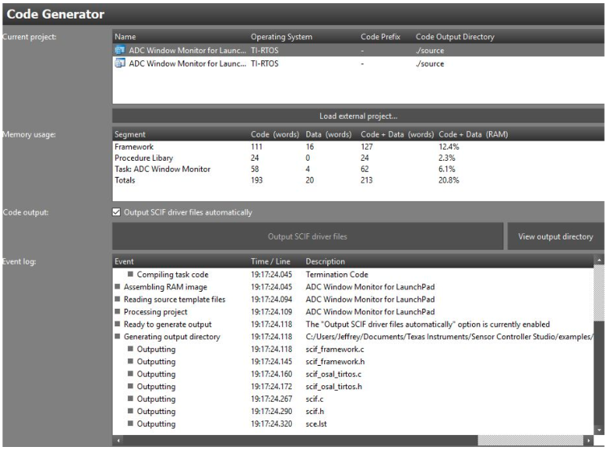

----------------------------------------------------------------------

**Task 02**: Download and Debug with SCS

Youtube Link: https://www.youtube.com/watch?v=Oj_j_UyHPRg

———————————————————————————————————

**Task 03**: Download and Debug with SCS

Youtube Link: https://www.youtube.com/watch?v=7aOsQJvuh6g

———————————————————————————————————

**Task 04**: Understand

Figure1: Graph of adc output